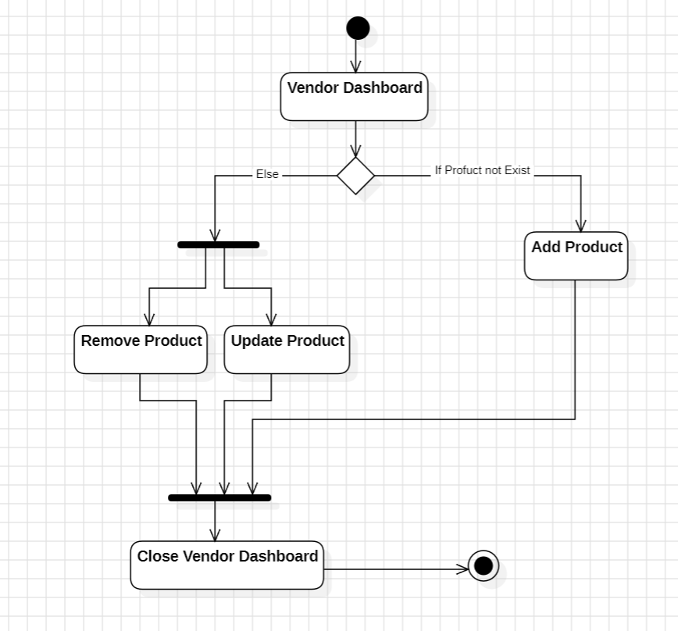

Fig: Activity Diagram of Product Addition on Ecommerce Application